POWER BI: CHARTS

Bar & Column Charts

The Basics: Bar & Column Charts

Bar and Column Charts are one of the most common ways to visualize data. Both of these data visuals use rectangular bars where the size of the bar is proportional to the data values.

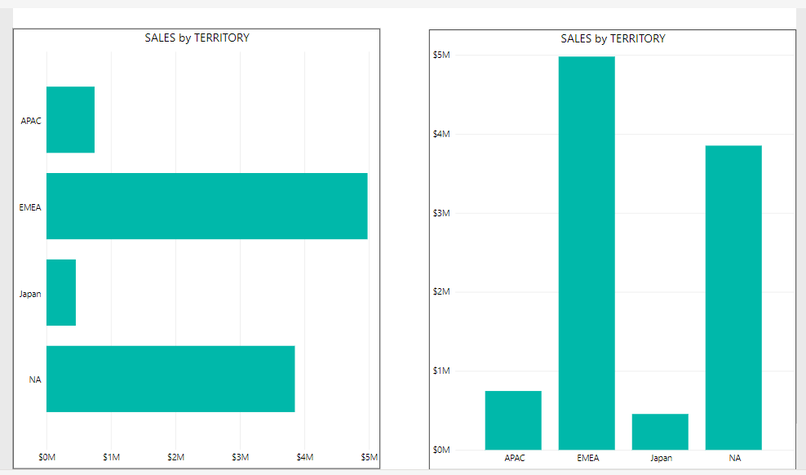

Fig 1-a: Comparing Bar vs Column Charts.

Column and bar charts let you compare different categories or track changes over time. What is the difference? If the rectangles are stacked horizontal, it's called a bar charts. If they are vertically aligned like towers, it's called a column chart (see fig 1-a above).

If the dimension on the x-axis is not a date and the names of the categories are long, it might be best to go with a bar chart rather than a column chart.

Some Example Interactive Graphs Using Power BI (expand for full view)

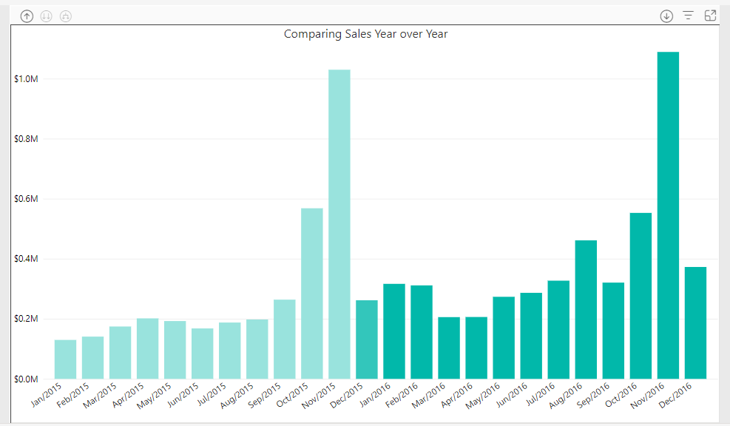

Fig 1-a: Comparing sales month over month using a standard column chart.

This is a pretty standard column chart showing sales data over a two year period. It is recommended to seperate the two years with a different color when comparing sales between two given years, with the previous year being a lighter shade. While you can hover over each bar to compare sales, it would be nice to have a better side by side comparison to see which months did better or worse.

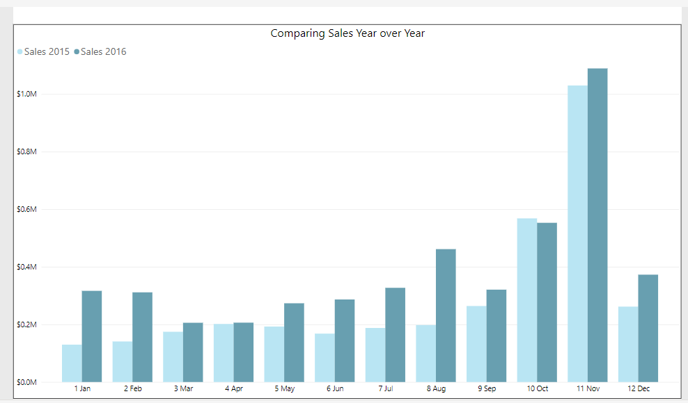

Fig 1-b: Comparing Sales Month over month using with a clustered column chart.

A clustered column charts is essentially a column chart that lets you compare two values side by side. In this case we are comparing sales for each month over a period of two years. Hovering over one of the values lets you see the % difference between the selected month and the sales values. A stacked column chart is very similar except the bars for each month will be stacked on top of each other rather then side by side. It is now easy to compare sales data last year vs this year for each month. For this sample data, October was the only month sales were down compare to last year.

Line & Area Charts

The Basics: Line & Area Charts

Line charts are used to track changes over time. They are used over column charts when there are multiple groups you want to spot trends for or tracking small changes over time. An area chart is similar to a line chart, except the area under the line is shaded in.

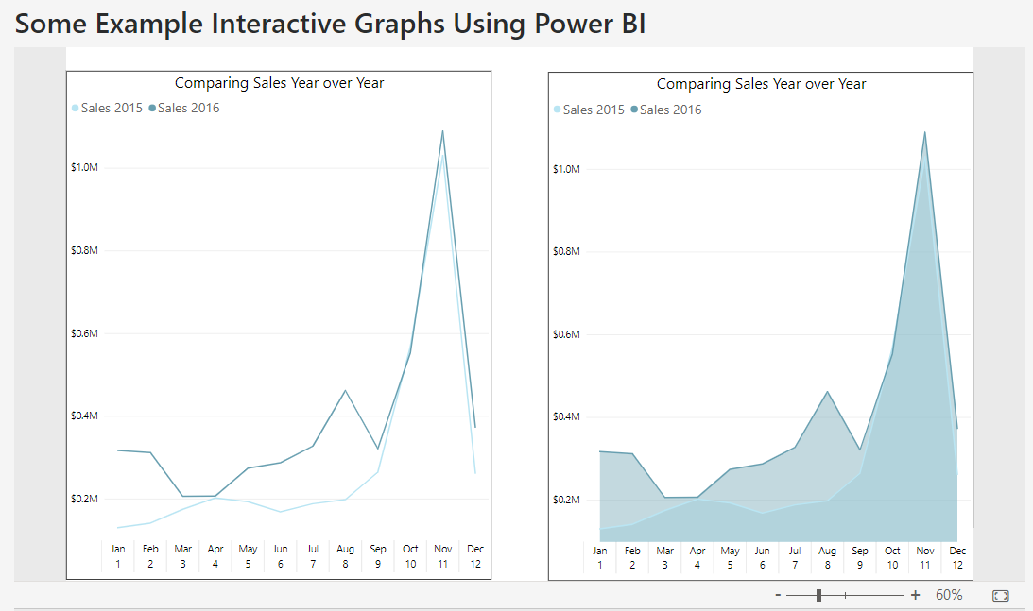

Area charts are very similar to line charts. They both show quantitative data with a time period on the x-axis. A stacked area chart is used to compare each category of the data against the whole. For instance in Nov there was just over 2 MM in sales for 2015 and 2016. We can see that Nov 2015 and Nov 2016 contributed roughly 50% each to the total. Where in this case the total is year 2015 + year 2016. Hovering over the graph lets you compare month over month.

POWER BI: Slicers

The Basics: Slicing your data

Basics of Slicers:

A slicer is a visualization tool that filters and segments data. It allows you to filter by specific dimensions (i.e by product type or city) or by a set criteria (ex. large transactions).

When you select an item in the slicer, only that item will be shown and the rest of the data gets filtered out. For instance take your entire sales data. You can set up slicers to look at sales by product, region, date or a particular customer demographic.

How to make a slicer:

To make a slicer select the slicer visual in Power BI under *Visualizations*. Next choose the column in your data set that you want to filter. You can also create a custom column know as a calculated column.

Power BI demo:

Below is an example of how slicers can bring your report to life

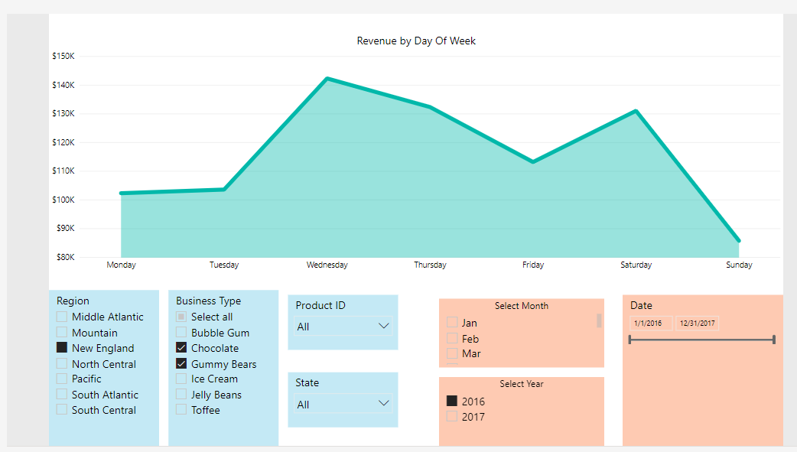

Additional Comments:

This example is a static report. However automating a report like this is easy. If your data is connected to a database where data gets updated daily or in real-time you can write a SQL query that always gets the last full week of data. If your data is still in excel files, you can also update the data in excel without having to recreate reports. Another variation is comparing this week vs last week in an automated report.

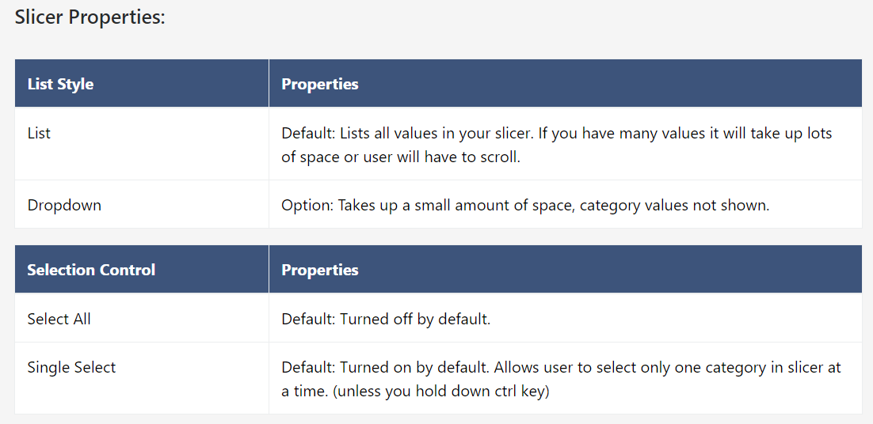

**Combo Charts**

The Basics: Combo Charts

Combo Charts are line charts and column charts shown together in one graph. The data can have completely different units and will have two y-axis rather than one y-axis. They are a great way to show a visual representation of your data in one graph. The examples below show the difference between a line and clustered column chart vs a line and stacked column chart. A line and clustered column charts is where the columns are shown side by side rather than stacked. It is common to show revenue and roi in a combo chart.

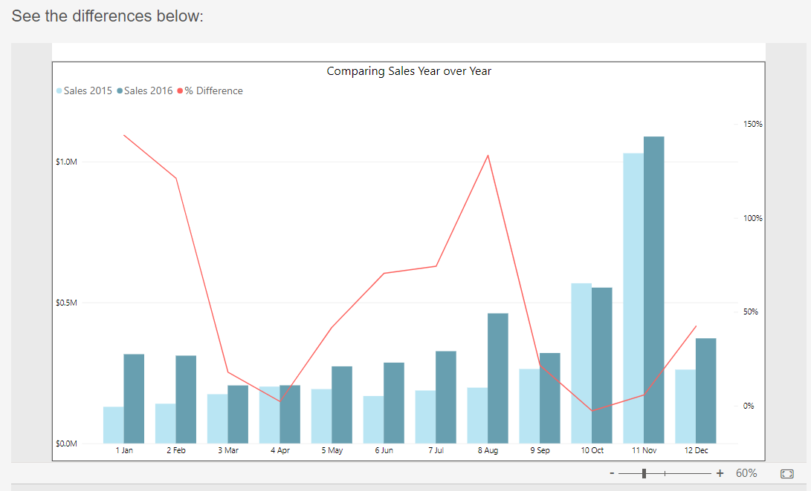

Fig 1-a: Line and Clustered Column Chart

This line and clustered column chart compares sales amounts using a clustered column chart and overlays a line graph to show the percentage differences for each month.

Some Example Interactive Graphs Using Power BI

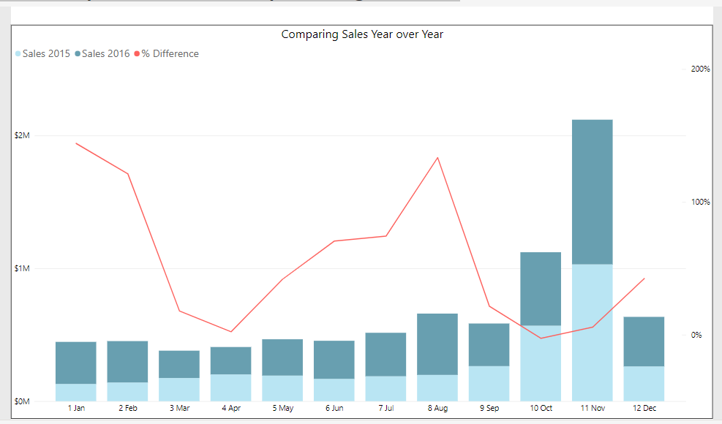

Fig 1-b: Line and Stacked Column Chart using tool tip feature

Of the two charts above, for this example we recommend using the line and clustered column chart since it is easier to compare the sales data values. Notice also that the latest year is on the right side, while 2015 data is on the left side. To most readers this will appear more natural since a later date should appear to the right or top.

In this example, the % difference is shown as a line graph. We can see that there was only one month, October, where sales was less than the year before (i.e dropping just under the 0% line.) We can also see that January and August performed much better than the year before.

POWER BI: Scatter Plots

The Basics:

Scatter plots (aka scatter graphs, or scatter diagrams) is a graph that plots two variables to see how they are related. The relationship between these two variables can be linear (ie. y = mx + b) or non linear (ie. y = x^2).

Power BI Demo:

Below are some examples of scatter plots using POWER BI. The graphs are interactive and you can slice the data by team or player position. Scrolling over the data points will give you information about the player such as salary, goals, assists, points, and earnings per point. We can see that there is a a fairly weak relationship between goals scored and salary. There is also a color saturation applied on the points scored (higher points, darker color). You can expand the graph below at the bottom.

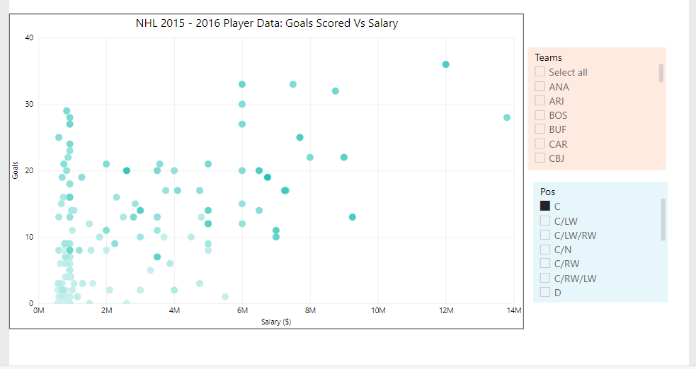

POWER BI: Waterfall Charts

The Basics: Waterfall Charts

Waterfall charts are a great way to visualize data and understand the cummulative effects of your data over time. You can also use a waterfall chart to show how much each component contributes to the final total amount. A waterfall chart tells you a story from your data by showing you how each positive or negative effect influenced the final outcome.

Some Example Interactive Graphs Using Power BI

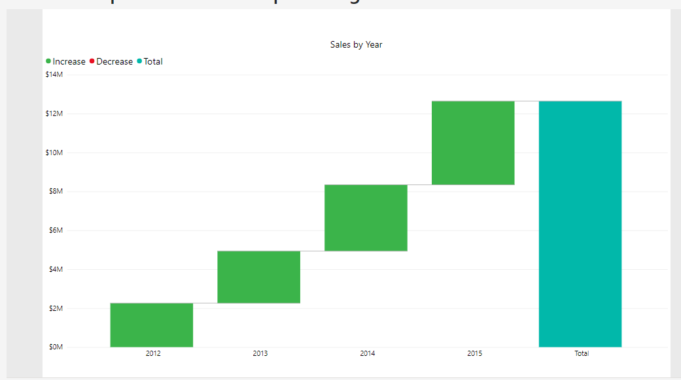

Fig 1-a: Waterfall Chart: Sales Data

In the sales waterfall chart above we can drill down by selecting on the top right drill down arrow and then selelcting one of the data bars. You should see the data change to give you a break down of sales by year, quarter month and even day. This drill down feature allows us to see a top down high level view of the data while allowing for a data deep dive if needed.

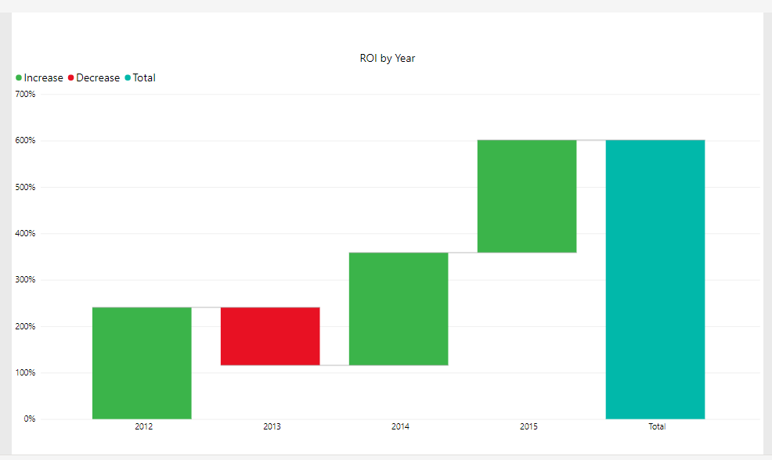

Fig 1-b: Waterfall chart ROI Data

For ROI, the total amount bar is not the true return over the given period. We see that for data where we have one value divided by another, we need to be careful in how we interpret the total column. If instead we used profits rather than ROI we would see an accurate total on the right. Note:The components that make up the total accurately reflect the ROI for this sample dataset.

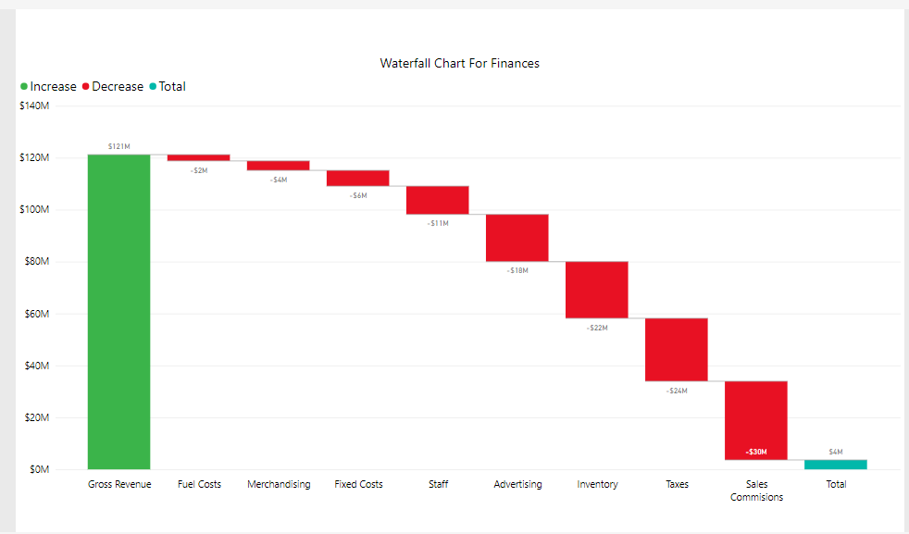

Fig 1-c: Waterfall Chart for Finances

A waterfall chart like the one shown above can be a useful visual to see how each component of a business contributes to the total revenue. For costs, a negative was added to each value to give to waterfall chart illustrated below. The final total gives Net Revenue. We could further expand on this graph by adding a breakdown for each component when selected. For instance the advertising component could further show a breakdown of online advertising, tv advertising, radio, print. Then too, each component of advertising could have its own component. For example online adverstising could be broken down in to Google AdWords, Facebook Ads, etc...

POWER BI: Funnels

The Basics: Funnels

A funnel is a series of steps a user must take to complete an action that you want them to do. Online marketers go on about funnels all the time and with good reason. Understand your funnel is essential in online businesses, as it allows you to see where users are dropping off along various parts of your site. For instance a form completetion or an online checkout can be broken down into various steps that needs to be completed in order. Let's look at a an ecommerce store example:

* STEP 1: User vists your website.
* STEP 2: User vists your visits a product page.
* STEP 3: User adds product to cart and proceeds to checkout page
* STEP 4: User purchases item

We can see the above steps need to be completed one after the other to reach a desired action. A desired action is known as a conversion (in this case purchasing the item). Of course not all visitors to the site will result in a conversion! The proportion of visits to conversions ( conversions/visits ) is known as the conversion rate (aka the most thrown around term in all of digital marketing). Let's look at a simple example:

* STEP 1: 100 users visit your site.
* STEP 2: 80 of those 100 users visits a product page.
* STEP 3: 20 of those 80 add a product to your cart.
* STEP 4: 1 of those 20 makes a purchase

In this scenario our entire funnel conversion rate would be 1% (1 purchase/100 visitors).

Also our conversion rate along each step of the funnel would be 80%, 25%, and 5% respectively. This is better known as your page to page conversion rate. Note also that the product of each of your page to page conversions will give you your total funnel conversion rate: (i.e 80%*20%*5% = 1% ). See diagram below for a clear picture.

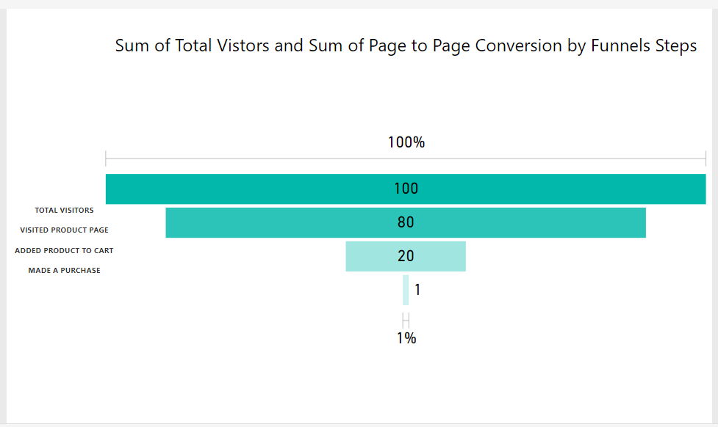

Fig 1-a: Simple Marketing Funnel

Some Examples of Interactive Funnels

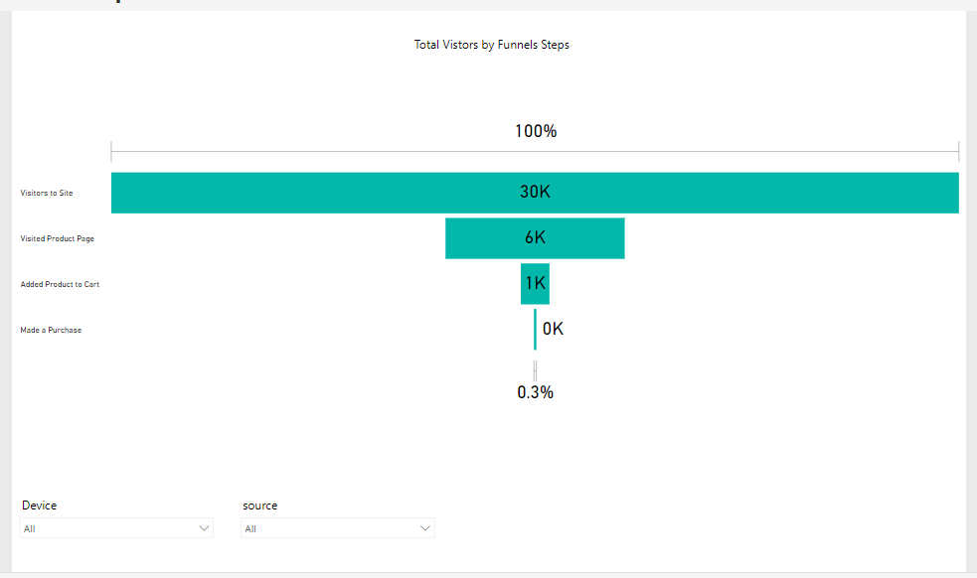

Fig 1-b: Interactive Funnel Segment by source and device.

The graph lets you select device and source to see the vistor drop off by source and device. This is a great way to see if there can be any improvements on a particular device, and compare traffic quality for different marketing channels. It is often the case the different sources, ie Facebook and Google will have different convesion rates on your site. Also there tends to be differences between conversion rates across devices. When testing, you should measure by source and/or device if you have enough traffic.

While Funnel charts give a visual representation of drop off rates across each step in your funnel, you may want to have a table representation of your data as well, shwoing conversion rates only each step. Belows give an example of a table style view. Though not particularly pretty, it shows you conversion page to page conversion rates by source and device.

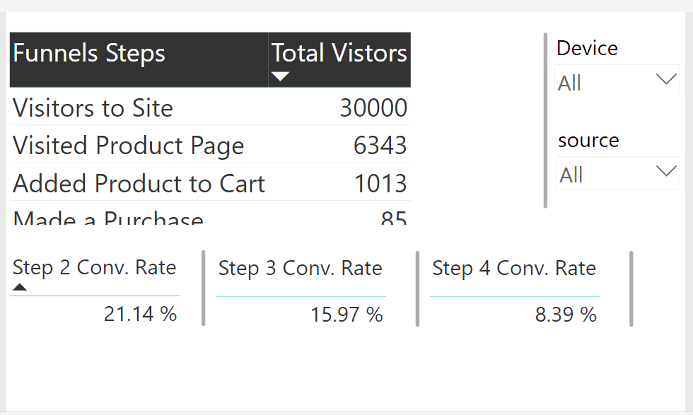

Fig 1-c: Displaying the page to page (step to step) conversion rate along each part of the funnel.

This a table style view of the marketing funnel above. By selecting source and device can you see which medium and step might by a cause concern? If you answered source: Facebook, device: Mobile and Funnel Step: Add Product to Cart you would be right!

POWER BI: Gauges and KPI Cards

Gauges

The Basics:

Gauges are a simple yet effective visualization for a dashboard. Using a gauge or KPI card gives a quick snapshot of your main KPIs. The main features of a Gauge are:

* Track performance overtime for a specific metric
* Illustrates a KPIs current value and goal or target value.

Power BI Demo:

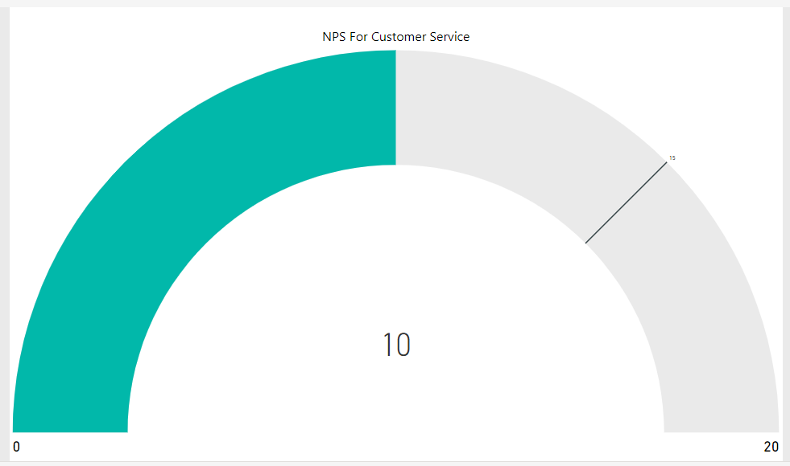

Fig 1-a: Standard Gauge Showing NPS

You can import this visual from the [visual gallery](https://app.powerbi.com/visuals/show/DialGauge1450749964276)

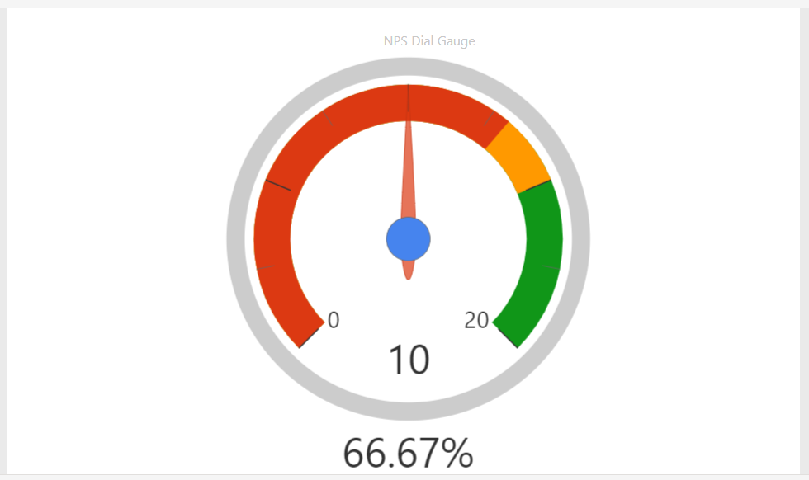

To make a Dial style gauge above with three colors we need to have the following values:

* Pointer Value: ie. Current NPS above set to 10
* Min Value: ie. Minimum NPS above set to 0
* Max Value: ie. Maximum NPS above set to 20
* Actual Start Value: ie. OK NPS above set to 13
* Target End Value ie. Goal NPS above set to 15
* Percentage Value ie. Current NPS / Goal NPS

Fig 1-c: Tachometer Style Gauge

To make a Tachometer style gauge above with three colors we need to have the following values:

* Current Value: ie. Current NPS above set to 10
* Start Value: ie. Minimum NPS above set to 0
* End Value: ie. Maximum NPS above set to 20
* Range 2 start Value ie. OK NPS above set to 13
* Range 3 start Value ie. Goal NPS above set to 15

Additionally you can set a target NPS Value if different than the "goal NPS" value. You must make sure that this target NPS value has a different value than any of the NPS values above, otherwise the graph will not show three colors for each range.

You can import this visual from the [visual gallery](https://app.powerbi.com/visuals/show/Tachometer1474636471549)

Try it out yourself with this simple excel data(gauges_upload.csv file)

Cards

The Basics:

Cards or KPI cards are also useful for displaying your main business metrics on your dashboard. For instance with KPI cards you can have your sales data, and then show your goal sales or projected sales numbers. You can also add in a trend axis which will show different colors depending on whether sales are up or down.

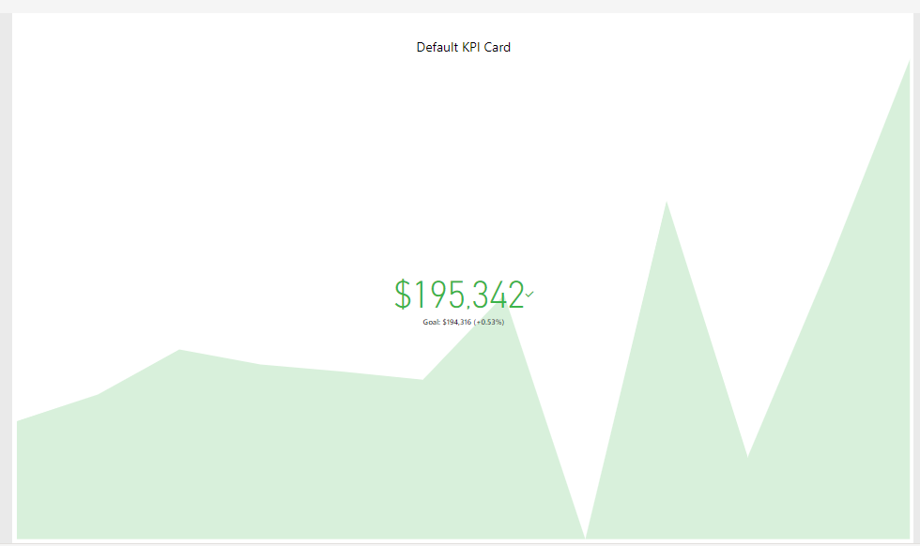

Fig 1-d: Default KPI Card showing Sales over time.

Features:

* Useful in a corner of a dashboard for a snapshot glance of your main KPIs.
* Trend axis shows changes over time.
* Goal value shows expected target to be reached.

POWER BI: Maps

Geography Maps

Basics:

Geography maps are a great top down summary visualization tool for your data if you have customers in several different cities or have customers from all around the globe. For geo maps you can zoom in and out to view city and/or country data. These maps even allow for very specific latitude and longitude coordinates.

Power BI Demo (geo map):

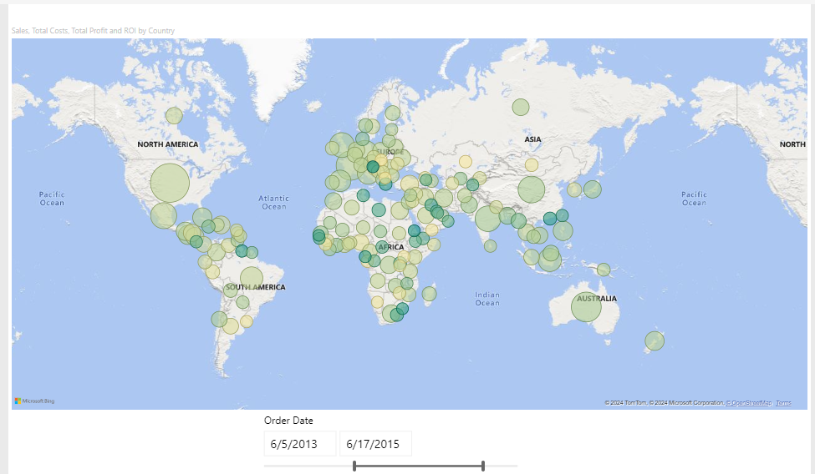

Fig 1-a: Sales and ROI data map by country

Features of a Geo Map:

* *Size:* Here size of circles is proportionate to revenue.
* *Color Saturation:* Color scale (greener is better) is proportionate to ROI
* *Tooltip:* Hover mouse over a specific circle to get more info for the at country.
* *Zoom:* Easily zoom in and out with the scroll of a mouse.

Power BI Demo (filled map):

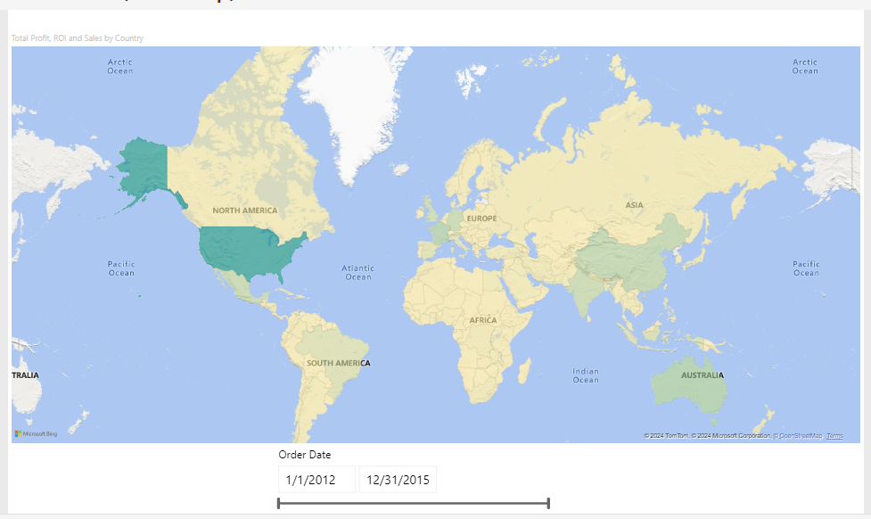

Fig 1-b: Filled Map in Power BI.

Features of the Filled Map:

* One dimension only. In this case sales revenue
* Entire country is colored, rather than a cirlce.
* *Color Saturation:* In this case, greener is higher revenue.
* *Tooltip:* Hover mouse over a specific circle to get more info for the at country.
* *Zoom:* Easily zoom in and out with the scroll of a mouse.

TreeMap:

Treemaps display hierarchical data as a set of nested rectangles. Each level of the hierarchy is represented by a colored rectangle called a branch node. Each branch contains smaller rectangles called leaf nodes. Power BI uses the measure value to determine the rectangle size for branches and leaves.

The rectangles are arranged by size with the largest branch node at the top left and the smallest branch at the bottom right. The arrangement of the leaf nodes within each branch follows the same order.

Consider a scenario where you need to analyze clothing sales data. You want to track product sales by clothing type and manufacturer. The branch nodes can represent the clothing categories: Urban, Rural, Youth, and Mix. The leaves can represent the clothing manufacturer data for products sold in each clothing category. The leaf nodes are sized and shaded based on the number of products sold.

The treemap represents the product sales hierarchy by clothing type and then by manufacturer.

If you have many data in grouping then go for TreeMap e.g., Categories and Sub-Categories

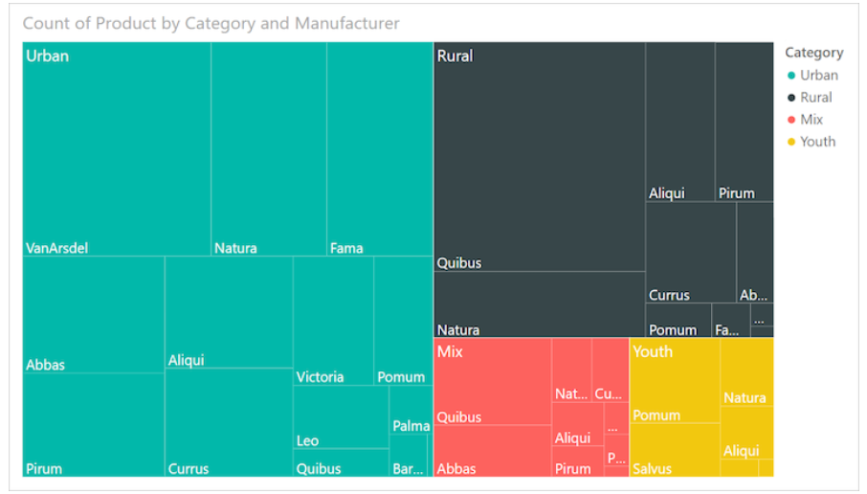

The largest branch node is for **Urban** clothing and the smallest branch is for **Youth**. Within each branch, the leaf nodes reveal the popularity of each manufacturer.

Let's look at some details:

* **Urban** clothing has the highest sales and **Youth** has the lowest.
* The most popular manufacturer of **Urban** clothing is **VanArsdel**. **Natura** and **Fama** are slightly less popular.
* There are similar product sales for **Mix** and **Youth** clothing.
* Across the four clothing types, clothes manufactured by **Natura** and **Aliqui** produce the best sales.
* **Salvus** yields fairly strong sales for **Youth** clothing, but the manufacturer isn't producing noticeable sales in other categories.

You can compare the number of products sold across the clothing categories by comparing the size and shading of each leaf node. Larger and darker-shaded rectangles (nodes) indicate higher value.

**When to use a treemap**

Treemaps are a great choice for many scenarios:

* Display large amounts of hierarchical data.
* Present a large number of values that can't be effectively shown with a bar chart.
* Illustrate the proportions between each part and the whole.
* Reveal the measure distribution pattern across each level of categories in the hierarchy.
* Show attributes by using size and color coding.
* Identify patterns, outliers, most-important contributors, and exceptions.

Radar Chart

Business Scenario:

You can use a radar chart to compare and measure data with multiple variables, and to identify outliers and commonalities. Here are some situations where a radar chart can be useful:

* Comparing features: You can use a radar chart to compare features or performance across multiple metrics. For example, you can compare computers based on features like memory, processing, and screen size.
* Identifying outliers: Radar charts can help you identify outliers, commonalities, and clusters of data with similar values.
* Measuring quality: You can use a radar chart to measure quality improvements and performance.
* Comparing spending: You can use a radar chart to compare allocated amounts versus actual spending.
* Charting strengths and weaknesses: You can use a radar chart to chart an athlete's strengths and weaknesses.
* Comparing products or services: You can use a radar chart to compare products or services.
* Comparing ordinal measurements: Radar charts are usually used for ordinal measurements, where each variable corresponds to "better" in some way.

# Overview

A radar chart is a graphical method of displaying multivariate data in the form of a two-dimensional chart of three or more quantitative variables represented on axes starting from the same point. The relative position and angle of the axes is typically uninformative.

Each variable is provided an axis that starts from the center. All axes are arranged radially, with equal distances between each other, while maintaining the same scale between all axes. Grid lines that connect from axis-to-axis are often used as a guide. Each variable value is plotted along its individual axis and all the variables in a dataset and connected together to form a polygon.

Radar Charts are useful for seeing which variables are scoring high or low within a dataset, making them ideal for displaying performance, such as Skill Analysis of Employee or sport players, product comparison, etc.

**RadarChart has 3 bucket fields: Category, Values and Images.**

1. Category - Field with a list of categories for each "radar" item. String values
2. Y axis - Field with values for Category field. It can accept many values. Also this field is used for cross filtering with other visuals.

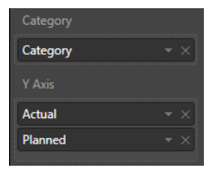

**Selection**

You can select any data point for data filtering and also you can use multi selection but only for one coverage area. For cleaning of selection you should click outside to "Сlear" button on the right top corner of a visual.

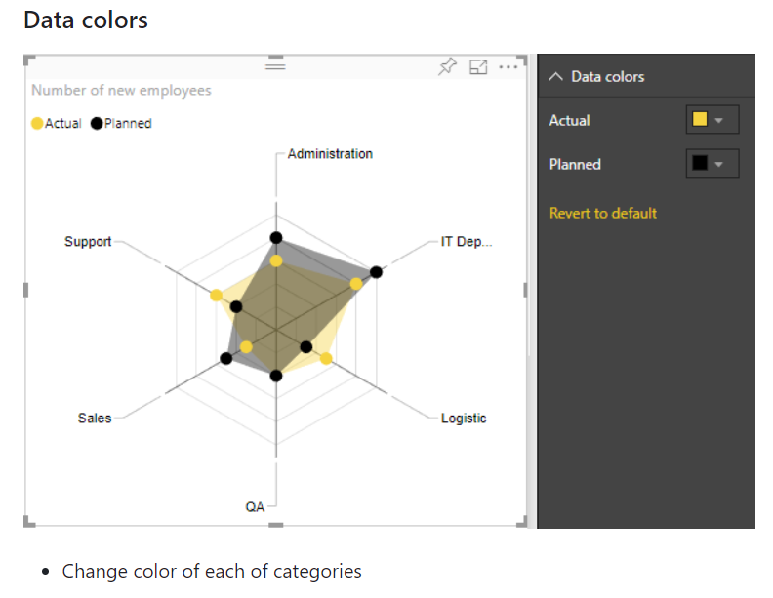

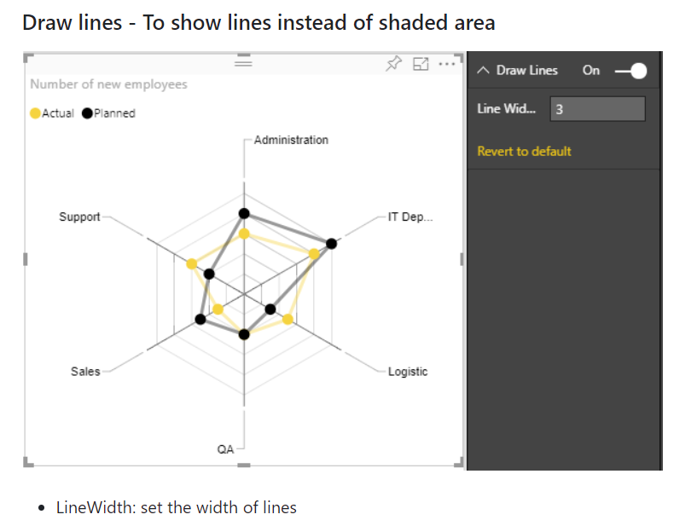

**Display Settings**

* Axis start: The value of this parameter indicates the beginning of the axis. By default Axis start is set to 0 if all values in DataSet are positive, but if data set contains values less then 0, then it'll be minimum dataset value under 0. Axis start cannot be greater than minimum value of dataset values. You can compare the difference when Axis start is changed on next two images:

